What Is An AI Agent?
In short, it’s automation.
But not like most people think: Press button → Get candy bar. Agentic automation is different because it has “agency.” It’s more like having a personal candy concierge.
You say, “I’m craving something sweet.” And then the agent:
- Checks what’s inside the vending machine
- Sees what’s in still available in the stockroom
- Remembers you’re allergic to peanuts and don’t like Funyuns
- Notices your friend across the table looks hungry and wants you to share
- And then hands you the perfect snack, all without you having to think through every step
A vending machine just executes one command. An agent understands the goal, evaluates options, chooses steps, and only loops you in when your judgment matters.
And with AI content agents, you can automate the repetitive content tasks that eat up 10-15 hours of your week with a few no-code tools, and a simple system to get it done.

How To Create An AI Content Agent From Scratch (7 Steps)
So how do you actually build one of these agents without any coding experience?
Most people think you need to be a software engineer. But the truth is, anyone can build a functional AI content agent in a weekend using no-code tools you are already using.
We’ve used this exact framework to build dozens of AI content agents for our business. And once you understand how the pieces fit together, you’ll wonder why you ever spent hours manually creating content in the first place.
Here are the steps:

Step 1: Define your agent’s job by choosing one specific content task it will handle.
The biggest mistake people make when building their first AI agent is trying to automate everything at once.
Don’t do that. Instead, pick ONE specific content task your agent will own. Maybe it’s writing social media posts. Maybe it’s drafting weekly email newsletters. Maybe it’s creating blog post outlines or repurposing long-form content into Twitter threads.
Think about where you spend the build of your time every week when creating content. Then write it down as a job description:
For example:
- “I want to turn my meeting transcript into LinkedIn posts”
- “I want to draft a newsletter from article links I save.”
- “I want to {job}, so I can {outcome}.”
The more specific you are, the easier the rest of this process becomes.
If you can’t explain the task in one sentence, you’re trying to automate too much at once.

Step 2: Map out the job workflow on paper and identify which tasks you want to automate.
Before you touch any tools, grab a piece of paper and sketch out your current workflow.
Write down every single step you take to create that content. Where does the raw material come from? What transformations happen? Where does it get published? Who reviews it? What happens if something needs to be fixed?

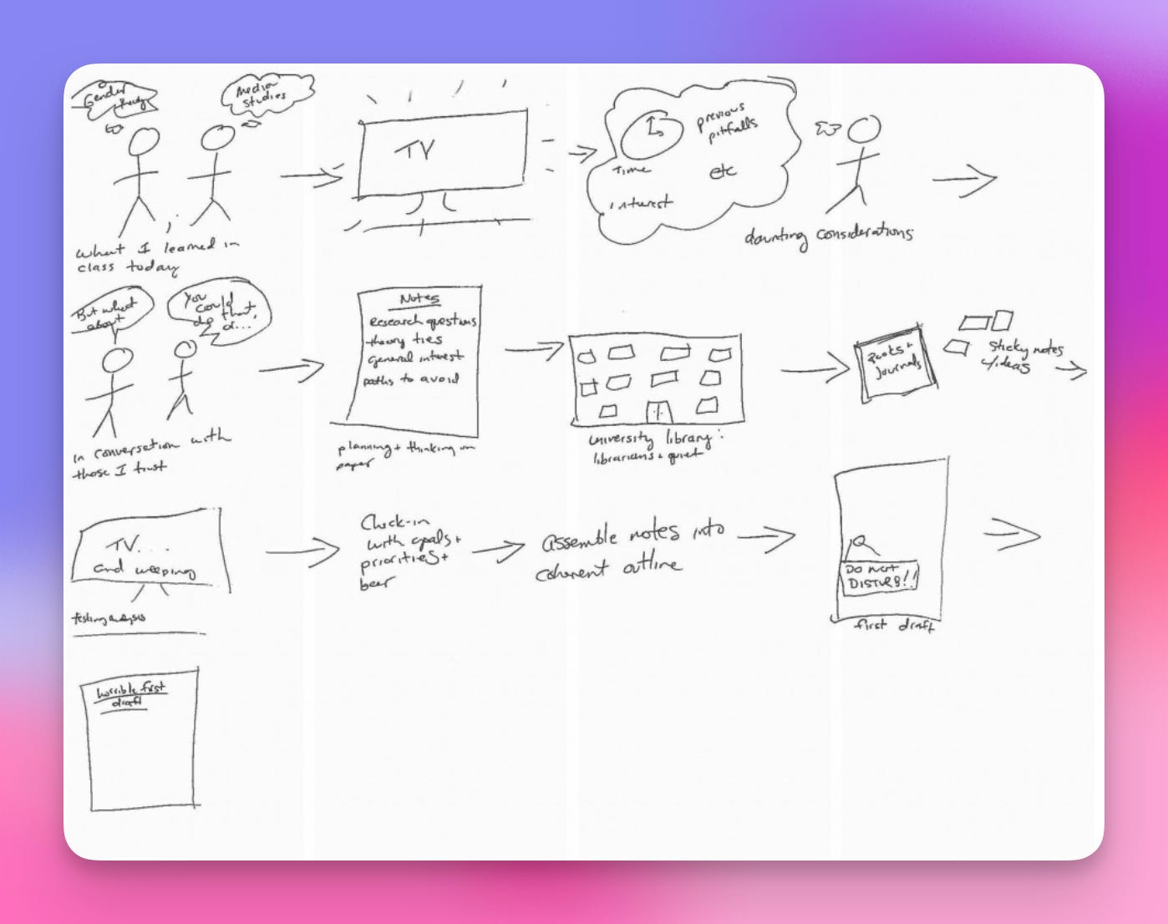

This is where most people discover they’ve been doing things the hard way for years.
For example, let’s say you’re automating LinkedIn posts. Your workflow might look like this:
- I write ideas in a Google Doc
- I paste them into ChatGPT to refine the hook
- I manually format the post for LinkedIn
- I schedule it in my content calendar
- I forget to post half the time
Now circle the repetitive tasks. Those are your automation opportunities. In this case, you could automate the ChatGPT refinement, the formatting, and the scheduling—saving yourself 30+ minutes per post

Step 3: Choose your no-code platform and connect the tools your agent will use.
Now it’s time to pick your automation platform.
The three best no-code platforms for building AI content agents are Make, Zapier, and n8n. Pick one and then connect the tools your agent needs. For most content agents, you’ll connect ChatGPT (via OpenAI API), Google Docs or Notion, Airtable for data storage, and whatever platform you publish to—LinkedIn, Twitter, email schedulers, etc.
Start simple.

Step 4: Write specific prompts for each step of the workflow so your AI knows exactly what to do with the data it receives.
This is where your agent goes from “meh” to “wow, this is actually good.”
Generic prompts produce generic content. Specific prompts produce content that sounds like you wrote it. So for every step in your workflow where AI does something, write a detailed prompt that includes:
- The exact task you want completed
- The tone and style you want (casual, professional, witty, etc.)
- Any formatting requirements (character limits, spacing, emoji usage)
- Examples of what “good” looks like
Again, the more specific you are, the better your results will be.

Step 5: Add conditional logic to handle different scenarios in your workflow.
Not all content is the same, so your agent needs to make decisions based on the data it receives.
This is where conditional logic comes in. Think of it as “if this, then that” rules that guide your agent’s behavior. For example, if the topic is “productivity,” then use a motivational tone or if the content includes a link, then add “Link in comments” to the post These rules make your agent smarter and more adaptable. Without them, you’ll end up with one-size-fits-all content that feels robotic.
Most no-code platforms have built-in conditional logic features (this is easier than it sounds).

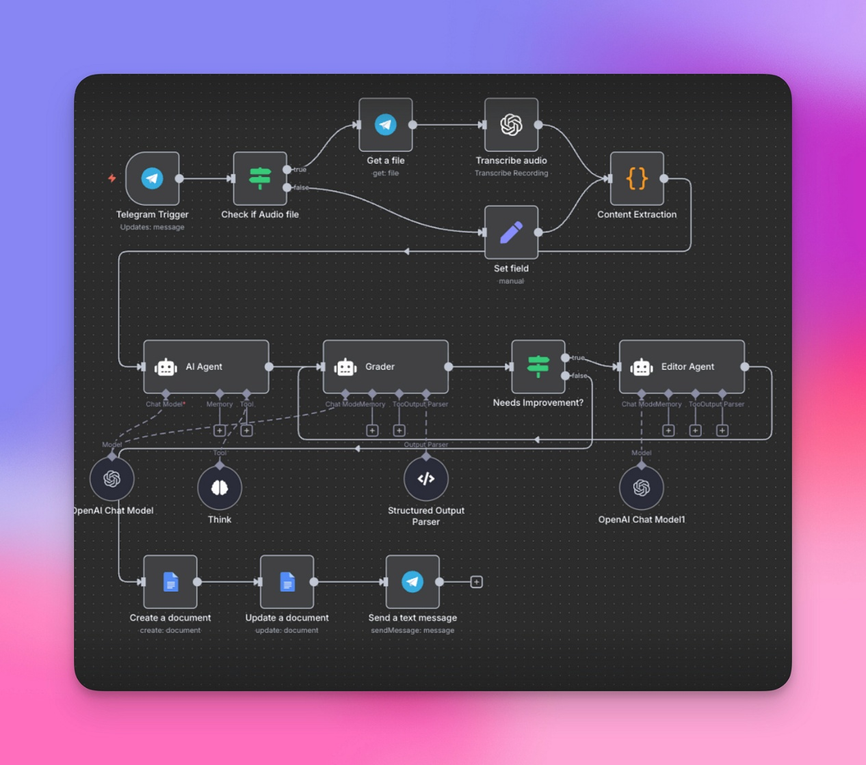

Step 6: Test your agent end-to-end with different content scenarios and watch where it breaks or produces bad output.
Your agent will not work perfectly the first time.
And that’s okay.
Run it through 10-20 different content scenarios and watch what happens. Where does it produce great output? Where does it completely fall apart? Does it follow your formatting rules? Does it sound like you—or like a robot? Take notes on every failure. Then go back and fix your prompts, adjust your conditional logic, or add quality control steps.
This testing phase is where your agent goes from 60% effective to 95% effective.
Don’t skip this step.

Step 7: Set up error notifications and human approval steps for quality control before anything gets published automatically.
Never, ever let your agent publish content directly without a human reviewing it first.
- I don’t care how good your prompts are.
- I don’t care how many tests you ran.
- AI makes mistakes.
Instead, set up your agent to send you a notification when content is ready for review. Most no-code platforms let you send content to Slack, email, or a Google Doc where you can quickly approve, edit, or reject it before it goes live. This gives you the best of both worlds: automation handles the heavy lifting, but you maintain final creative control.
You might eventually trust your agent to post directly—but start with human approval.

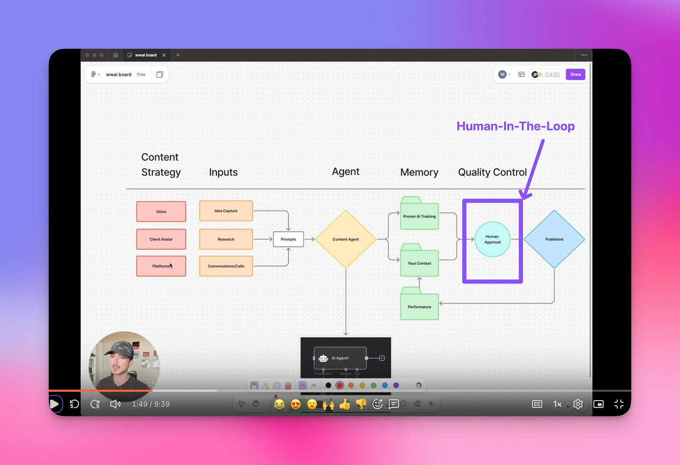

Example
Here’s what this looks like when it all comes together:
Mitch (our in-house agentic wizard) built an AI agent that turns our weekly PGA Hot Seat calls into LinkedIn posts.
Every Friday, Fathom sends the transcript to his n8n workflow. The agent pulls out the most interesting discussion points, writes three post options in our brand voice, and drops them in Notion for review. We pick one, make minor tweaks (usually just adding a personal example), and schedule it. The entire setup took Mitch about 6 hours following these exact steps.
Now it saves us 2+ hours every week, and we haven’t missed a case study post in 4 months. And it’s always written using a proven framework we designed.
Now, you might be wondering, why should I spend time building an AI content agent when I could just keep doing things manually?
It’s simple.

You’re Trading A Few Hours Of Setup For Hundreds Of Hours Of Freedom
Here’s why business owners who automate their content always outpace those who don’t:
- Your time becomes infinitely more valuable. Right now, you’re probably spending 10-15 hours per week on content creation—writing posts, editing drafts, scheduling, reformatting. That’s 40-60 hours per month. With an AI content agent, you compress that down to 2-3 hours of review time. Suddenly, you have 50+ extra hours to focus on revenue-generating activities like closing deals, building products, or spending time with your family.
- Your content output multiplies without burning you out. Most entrepreneurs hit a ceiling: they can only create so much content before they’re exhausted. But with an AI agent, you can 5x your output without working nights and weekends. Want to post daily on LinkedIn, send a weekly newsletter, and create Twitter threads? Done. Your agent handles the heavy lifting while you stay fresh and creative for the high-level strategy work only you can do.
- You build a content system that works even when you don’t. The real power isn’t just automation—it’s consistency. Your agent doesn’t take vacations. It doesn’t get sick. It doesn’t lose motivation on a bad day. Once it’s built, you have a content engine that runs 24/7, keeping your brand visible and your audience engaged even when you’re completely offline.
This is how you stop being a content hamster on a wheel and start being a CEO who owns a content machine.

Ready To Build Your Custom AI Agent Workflow?
Now, I know what you’re thinking: “This sounds great, but where do I actually start with MY specific content workflow?”
That’s exactly why I created a prompt you can use right now.

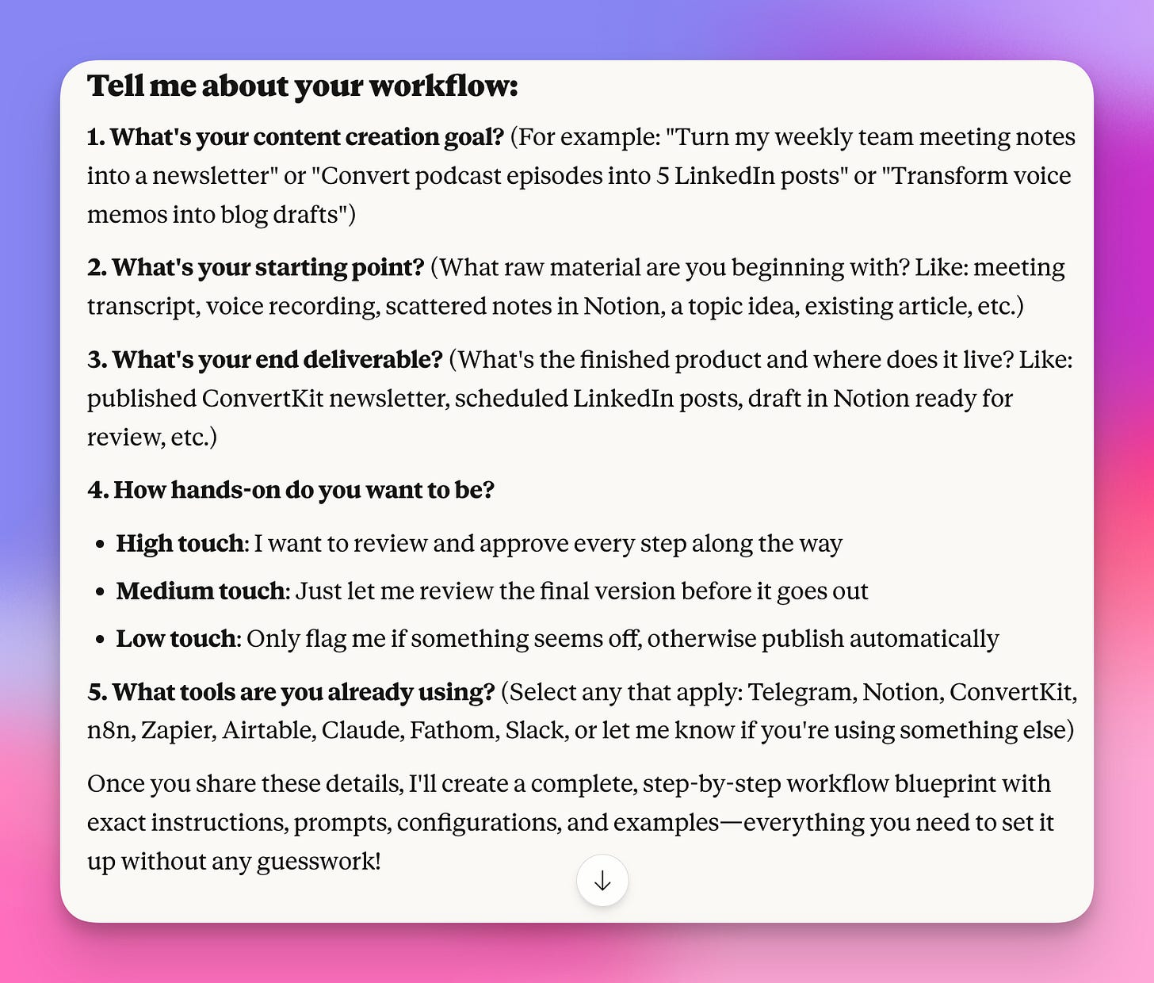

Copy and paste this into Claude, fill in the blanks with your specific content task, and it will generate a detailed, step-by-step blueprint to build your agent—even if you’ve never automated anything before:

AI Content Agent Workflow Builder
Welcome to your AI Content Agent Workflow Builder! ​
Below you'll find a powerful prompt that helps you:
Transform repetitive content tasks into automated workflows
Build AI agents that handle research, writing, and publishing (while you stay in control)
Create detailed, step-by-step blueprints that even the most non-technical person can follow
Let's dive in

3 Biggest Mistakes Creators Make Building AI Agents
Before you use this prompt, let's address the 3 biggest mistakes people make:
Mistake #1: Trying to automate everything at once. Don't automate your entire content operation on day one. Start with one workflow (like "meeting notes → newsletter draft"). Master it. Then expand.
Mistake #2: Cutting yourself out entirely. Fully autonomous agents sound cool, but they often produce generic content that doesn't sound like you. The workflows this prompt creates include strategic human review checkpoints—you approve, you add your voice, you make the final call.
Mistake #3: Not being specific enough about the goal. "I want to use AI for content" is too vague. "I want to turn my weekly team meeting notes into a newsletter draft, then publish to ConvertKit after I review it" is perfect. The more specific your input, the better your workflow blueprint.
Now let's talk about how to use this prompt.

How The AI Content Agent Workflow Builder Prompt Works
There are 3 steps:
Step 1: Run The Prompt Using Claude Full transparency, Claude works best for this prompt, but you can use it with any LLM with thinking mode turned on.
Step 2: Answer 5 Simple Questions The prompt will ask about your content goal, starting point, tools, and how hands-on you want to be.
Step 3: Follow Your Custom Designed Workflow (Paint By Numbers) After you run the prompt, Claude will give you a detailed workflow document with: Tool setup guides, Agent prompts you can copy-paste, troubleshooting, and human review checkpoints. All you have to do is follow the steps!
By the time you finish following the blueprint, you have a working system that handles the repetitive parts of content creation while keeping you involved in the decisions that actually matter.
Ready to build your first AI content workflow?

Here’s the prompt:
You are an expert in designing agentic content creation workflows for non-technical entrepreneurs. Your job is to create a detailed, step-by-step workflow blueprint that anyone can follow without additional research.

## INPUT REQUIRED FROM USER

First, gather this information:

1. **What is the content creation goal?** (e.g., "Write and publish a weekly newsletter from meeting notes" or "Turn podcast episodes into LinkedIn posts")

2. **What is the starting point?** (e.g., raw meeting notes, a topic idea, voice memo, existing article)

3. **What is the end deliverable?** (e.g., published newsletter, scheduled LinkedIn post, draft blog post in Notion)

4. **How involved do you want to be?**
- High touch (review every step)
- Medium touch (review before publishing)
- Low touch (only review exceptions/flags)

5. **What tools do you already use?** (Select from: Telegram, Notion, ConvertKit, n8n, Zapier, Airtable, Claude, Fathom, Slack)

## YOUR OUTPUT STRUCTURE

Once you have the user's answers, create a comprehensive workflow document with these sections:

---

### **1. WORKFLOW OVERVIEW**

Provide:
- One-sentence description of what this workflow does
- Visual workflow diagram using this format:
[Starting Point] → [Agent Step 1] → [Human Review] → [Agent Step 2] → [Final Output]
- Time estimate for setup and per-execution
- Key benefits of this workflow

---

### **2. TOOLS & SETUP REQUIREMENTS**

For each tool used, specify:

**Tool Name:**
- What it does in this workflow
- Account type needed (free/paid tier)
- Link to sign up
- Estimated setup time

Example:
**n8n:**
- Orchestrates the automation workflow
- Free self-hosted OR n8n Cloud starter ($20/mo)
- Sign up: https://n8n.io
- Setup time: 15 minutes

---

### **3. DETAILED WORKFLOW STEPS**

Break down into numbered steps with this level of detail:

**STEP X: [Action Name]**

**What happens:** [Plain English description]

**Tool used:** [Specific tool]

**Agent role:** [What the AI does autonomously]

**Human role:** [What the human reviews/approves - BE SPECIFIC about what they're checking for]

**Configuration:**
[Provide exact settings, prompts, or code snippets]
[Include field mappings, API endpoints, prompt templates]
[Format so they can copy-paste]

**Success criteria:** [How to know this step worked correctly]

**Troubleshooting:**
- Common issue 1: [Solution]
- Common issue 2: [Solution]

---

### **4. AGENT PROMPTS & INSTRUCTIONS**

For each AI agent interaction, provide the EXACT prompt template:

**Agent Prompt for [Step Name]:**
[Full prompt here - include system instructions, examples, output format requirements]
Variables to replace:

{{variable_name}}: [what to insert here]

**Self-Correction Logic:**
[Explain how the agent should check its own work and iterate]

Example:
"After drafting, the agent should:
1. Count words (target: 800-1000)
2. Check for at least 3 section headers
3. Verify one CTA is included
4. If any fail, revise and recheck"

---

### **5. HUMAN-IN-THE-LOOP CHECKPOINTS**

List each review point:

**Checkpoint #X: [Name]**
- **When:** [At what stage]
- **What to review:** [Specific checklist]
- **How to approve:** [Exact button/action in tool]
- **How to request revisions:** [Specific instructions]
- **Approval time estimate:** [X minutes]

---

### **6. TOOL-SPECIFIC SETUP GUIDES**

For each tool, provide a mini-tutorial:

**[Tool Name] Setup**

Prerequisites:
- [List any dependencies]

Step-by-step:
1. [Action 1 with screenshot description or exact menu path]
2. [Action 2...]

Configuration values:
Field Name: [exact value to enter]
API Key: [where to find it - exact navigation path]
Webhook URL: [format or example]

Integration connections:
- Connect [Tool A] to [Tool B]: [exact steps]

---

### **7. ITERATION & ERROR HANDLING**

**Agent Self-Correction Process:**
[Describe how agents improve their output automatically]

**Error Scenarios:**
| Error | Likely Cause | Solution | Prevention |
|-------|--------------|----------|------------|
| [Error description] | [Why it happens] | [Fix steps] | [How to avoid] |

**Quality Checks:**
- [Automated check 1]
- [Automated check 2]
- [Human review check 1]

---

### **8. EXAMPLE RUN-THROUGH**

Provide a concrete example:

**Input:** [Actual example content]

**Step 1 Output:** [Show what the agent produces]

**Human Review Notes:** [What a human might flag]

**Step 2 Output:** [Show the iteration]

**Final Output:** [Complete deliverable example]

---

### **9. OPTIMIZATION TIPS**

After they're running:
- [Tip 1 for improving quality]
- [Tip 2 for saving time]
- [Tip 3 for scaling]

---

### **10. QUICK START CHECKLIST**

- [ ] Tool 1 account created and configured
- [ ] Tool 2 connected to Tool 1
- [ ] Agent prompts loaded and tested
- [ ] Test run completed successfully
- [ ] Human review process documented
- [ ] Error handling tested

---

## IMPORTANT GUIDELINES FOR YOUR OUTPUT:

**DO:**
- Be extremely specific (include exact button names, field labels, menu paths)
- Provide copy-paste ready prompts and configurations
- Include realistic time estimates
- Anticipate common problems
- Show actual examples
- Explain WHY each step matters
- Use simple, jargon-free language

**DON'T:**
- Assume technical knowledge
- Skip steps that seem "obvious"
- Say "configure as needed" - give exact values
- Use vague language like "set up the integration"
- Forget to specify free vs paid tiers
- Leave out error handling

## TONE:
Encouraging, clear, detailed but not overwhelming. Like a patient expert friend walking them through it.

---

Now, gather the user's input and create their custom workflow blueprint!

